PROCEDURE DESCRIPTION OF ACTIVITY MONITORING, VERIFICATION AND APPROVAL OF ACTIVITY AND FINANCIAL REPORTS OF PROJECTS FINANCED BY THE FUNDS OF THE GOOD WILL FOUNDATION OF COMPENSATION FOR THE IMMOVABLE PROPERTY OF JEWISH RELIGIOUS COMMUNITIES

General Provisions

- Procedure description of activity monitoring, verification and approval of activity and financial reports of projects financed by the funds of the Good Will Foundation of Compensation for the Immovable Property of Jewish Religious Communities (hereinafter - Description) regulates the order of PE “The Foundation for Disposal of Good Will Compensation for the Immovable Property of Jewish Religious Communities” (hereinafter - GWF) of planning and performing the administrative actions which are associated with verification of these projects and their reports and verifications in the places of implementation and administration (hereinafter - spot checks).

Monitoring of Project Activity

- Monitoring of project activity is performed by GWF in these manners:
  - Verification of activity and financial reports submitted by the project executor;
  - Analyzing all documentation (agreements of project financing (support), descriptions of activities, budgets) of projects implemented during the period while GWF is financing the project; analysis is performed by using the cross-checking method;
  - Performing spot checks;
  - Consulting project executors constantly in order to identify and help them to solve relevant questions about project administration and implementation.
- All projects are examined by using the method stated in Article 2.1. Selected projects might be examined during or after spot check by using the method stated in Article 2.2. Projects can be examined by using the method stated in Article 2.3.

Verification and Evaluation of Activity and Financial Reports

- Activity and financial reports (the full set of reports including the supporting documents of costs and activities) should be examined and approved by GWF’s responsible persons within 90 calendar days after submitting the full set of reports to GWF.
- GWF’s employees responsible for the inspection of activity and financial reports examines whether the information in reports are correct, accurate, thorough, not misleading, whether it fully complies with the requirements of the Agreement on Partial Financing of the Project (hereinafter – Agreement) and do not conflict with the legislation of the Republic of Lithuania.
- Initial verification of the set of reports before sending notes is performed in the numerical order in which these reports were submitted.
- Current activity and financial reports filled correctly by the project executor are confirmed by the GWF’s responsible employees by sending a notification to the project executor.
- Verification results of the set of reports are declared by GWF’s responsible employee by filling
Project summary table (Appendix 3) and The Announcement on

Confirmation of the Project Report (Appendix 4). Project executor shall be informed in written immediately about the results of reports’ verification. Project executor is e-mailed with the copy of The Announcement on Confirmation of the Project Report by using e-mail address indicated in the Agreement or in other written documents submitted to GWF.
- After identifying shortcomings in activity and (or) financial reports and supporting documents of costs and activities, the written notes about corrections are sent to the project executors. 5 working days is a maximum period for eliminating shortcomings. After this period, the shortcomings identified might be considered as ineligible project costs/ as the project activities which were not performed in full extent.
- All the procedure of project verification, implementation of activities and evaluation of eligibility of expenses is considered complete after the verification of final set of reports (last project quarter, as it is foreseen in Project documentation) by the responsible GWF personnel. After the verification of final set of reports, the reports are not revised (not corrected), additional appendices of the report (copies of the documents) are not sent to GWF and not examined. This restriction does not apply to the audits carried out on the initiative of the GWF: the GWF, in exercising the right set out in the Item 71 of the Guidelines to conduct on-site inspections of project activities and expenditures in five years after the end of the implementation of project activities, has the right to request documents and explanations related to the project, and the project executor must submit them within the deadline set by the GWF. If it is determined that the approved expenditures were ineligible for financing, the GWF shall formalize the results of the inspection in the Project Inspection Report (Annex No. 2) and shall set a deadline within which the relevant part of the funds shall be returned to the GWF. The actions of the responsible GWF personnel may be subject to appeal following the procedure indicated in Chapter VII.
- Activity and financial reports together with documents justifying expenses and activities, documents of correspondence regarding elimination of deficiencies and announcement regarding project report approval are added to the project‘s file or are stored electronically after the verification and approval by the responsible GWF personnel.

The Objective of the Spot Checks

- GWF may perform unplanned spot checks on the projects.
Unplanned spot checks are performed by GWF, if there is a suspicion that the information submitted by the project executor is inaccurate, incomplete or misleading. Unplanned spot checks are performed under the order of GWF director according to the received complaint, notification, request, assignment, public information, etc.

Planning and Performing Project Spot Check

- GWF can check the activity of project executor only as far as it is associated with the implementation of the verified project.
- Spot check is performed by the Spot check work group (not less than 2 persons) formed under the order of GWF director.
- Persons responsible for spot check process, before performing the spot check, have to review the verification results of projects’ activity and financial reports. Categories of project’s costs with mistakes must be considered with greater attention.
- If the information in advance about unplanned spot check of the project executor might have a negative impact on the results of spot check, then GWF can perform spot check without informing the recipient of funding in advance.
- Members of Spot check work group must:
  - Suspend themselves or be suspended from their duties to perform the spot check, if it emerges that they are the spouses, cohabiting partners, partners in a registered partnership, close relatives of the head or project executor of verified institution or members of project working group or they are associated with these persons by affinity relations (as it is stated in Civil Code of the Republic of Lithuania (Žin., 2000, Nr. 74-2262)) or if there are reasoned doubts about the impartiality of members of Spot check work group due to other reasons which may cause the conflict of private and public interests;
  - Be objective and fair, do not assess the results of performed verification in advance and publicly;
  - Analyze the material gathered during the verification and assess whether the information provided in the reports of project execution by recipient is correct and accurate, whether the works and researches were done, services were provided and items were purchased and project executor has settled for the latter, whether the funds are used for its intended purpose, and write down the results of spot check in The Paper of Project Verification.
- Spot check work group has the right:
  - To perform spot checks in institutions during their working time;
  - To review the documents associated with the subject matter of the spot check and to receive the copies of these documents in the institutions, also, if there is a possibility, to receive the information associated with the spot check;
  - During the unplanned spot check:
    - Considering the reasons and objectives of the spot check, data and documents, indicated in the list of verification elements, are checked;
- During spot check documents chosen randomly are checked.
- During unplanned spot checks project executor and partners can be also asked to submit the funding agreements with appendixes (descriptions of activities, budgets) of other projects
- The Paper of Project Verification is introduced to the project executor after performing the project spot check.
- Spot check results, conclusions and recommendations on the further implementation of the project are proposed in The Report of Project Verification (Appendix 2). If it is necessary, obligatory directions and recommendations are set for the project executor.
- GWF representatives, who have participated in the spot check process, formalize results of spot check in the form of The Report of Project Verification within 30 calendar days. Project executor is introduced with the report in written. The copy of The Report of Project Verification is e-mailed or sent via mail by the address provided in the Agreement.
- GWF director must be informed immediately about the spot check that did not happened by the fault of project executor, corrections of irregularities and/or recommendations not performed after the spot check. GWF Board can declare the decision to finance the project as non-valid anymore or take other preventive measures if that type of violations are found.

Administration of Irregularities Identified during the Spot Checks

- After detecting inessential discrepancies during the spot check, recommendations are formulated for the project executor and the period of 30 days (in exceptional cases the longer period can be set by agreeing in writing mutually) is set to implement these recommendations.
- After detecting essential infringements of the Project financing agreement, GWF:
  - Suspends analysis of project reports and payments of the funds till the project executor removes all infringements within the required time;
  - Has the right to terminate the Agreement with the recipient of the funds and/or to demand the repayment of the paid funds (or a part of it);

- After performing the spot check, if it is suspected that infringements done by the project executor are of criminal nature, then GWF management must be informed immediately, but not later than within 2 working days after the project spot check.
- Project executors must inform GWF in written about the correction of detected infringements and implementation of recommendations.

Claims and Complaint Handling. Final Provisions

- Project executor can submit claims regarding the actions (decisions) of GWF administration to GWF director, related to verification and evaluation of activities and financial reports or inaction in written within 10 days since the day, project executor finds out, or should have found out about these GWF actions or inaction.
- After receiving the claim from project executor, GWF director handles it.
- If GWF director assess, that the actions of GWF administration were legal and meets the procedures/regulations established by the Good Will Foundation, director informs project executor about the assessment in written.
- If GWF director assess, that the actions of GWF administration were illegal and did not meet the procedures/regulations established by the Good Will Foundation, director orders to repeat the procedure of verification and evaluation of activities and financial reports or to perform other actions. In that case GWF director sets a period of not shorter than 20 days, during which the evaluation procedure have to be repeated or other necessary actions must be performed and informs project executor about the decision made in written.
- If project executor (recipient of funds) does not agree with decisions or actions of GWF, he/she can apply to a court in accordance with legal procedures established by Lithuanian Republic legislation.

Appendix 1 The Paper of Project Verification

Page of verification

(date and number of the Order / the objective of unplanned verification)

(date)

(location)

Data about the project and project executor according to the agreement of the project:
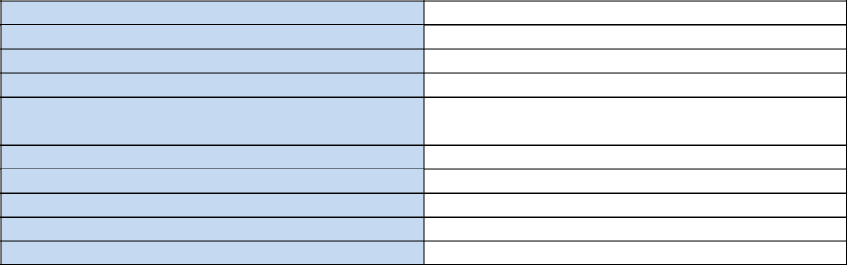
The title of project executor: Project executor’s company code:
Number of project financing agreement: Project title:
Contacts of project executor (address, phone, e-mail, contact person):
Value of the project (Euro):
Sum of the costs financed by GWF (Euro):

- Data about the project management and administration:

No. | Criteria of verification | Yes | No | Not | Comments on the reasons for
 |  |  |  | applicable | not following the conditions
2.1. | Are all necessary documents of
2.1. | the project kept according to
2.1. | the procedures set in project’s
2.1. | agreement?
2.1. | (are all original documents kept in a legally
2.1. | registered office?)
2.2. | Do the copies of documents
2.2. | justifying the costs and
2.2. | submitted by the project
2.2. | executor together with the
2.2. | reports correspond to the
2.2. | original ones?
2.2. | (not less than 20 copies of documents
2.2. | submitted to GWF are verified)

Data about the execution of purchase during the project, implementation of purchase agreements and income of the project:

No. | Criteria of verification | Yes | No | Not | Comments on the reasons for
 |  |  |  | applicable | not following the conditions
3.1. | Do the purchased items,
3.1. | supplied services, performed
3.1. | works correspond with the
3.1. | ones specified in the
3.1. | project’s agreement,
3.1. | purchase agreement and
3.1. | documents justifying the
3.1. | costs?
3.2. | Is fixed asset purchased during
3.2. | the project undamaged, not
3.2. | destructed, not lost because of
3.2. | fault and negligence of the
3.2. | project executor/partner? Has
3.2. | the property rights of fixed asset
3.2. | been not transferred (except the
3.2. | transfer to project’s partner)?

- Data about the project’s financing and accounting of project funds:

No. | Criteria of verification | Yes | No | Not | Comments on the reasons for
 |  |  |  | applicable | not following the conditions
4.1. | Does the project executor
4.1. | have the separate bank
4.1. | account in the credit
4.1. | institution for the project to
4.1. | keep project’s financing
4.1. | funds?
4.2. | Are entries of accounting  operations associated with  the project separated from  other operation entries (i.e.  are the separate sub-accounts  of account plan or coding  used)?
4.3. | Other, e.g., whether the complaint or other information received by GWF was confirmed.

Data about the execution of directions and (or) recommendations stated earlier for the project executor:

No. | Criteria of verification | Yes | No | Not | Comments on the reasons for
 |  |  |  | applicable | not following the conditions
5.1. | Have the project executor
5.1. | implemented or is implementing
5.1. | the recommendations or directions
5.1. | presented in reports of previous on-
5.1. | the-spot verification or presented in
5.1. | other ways?

- The list of inspected documents:
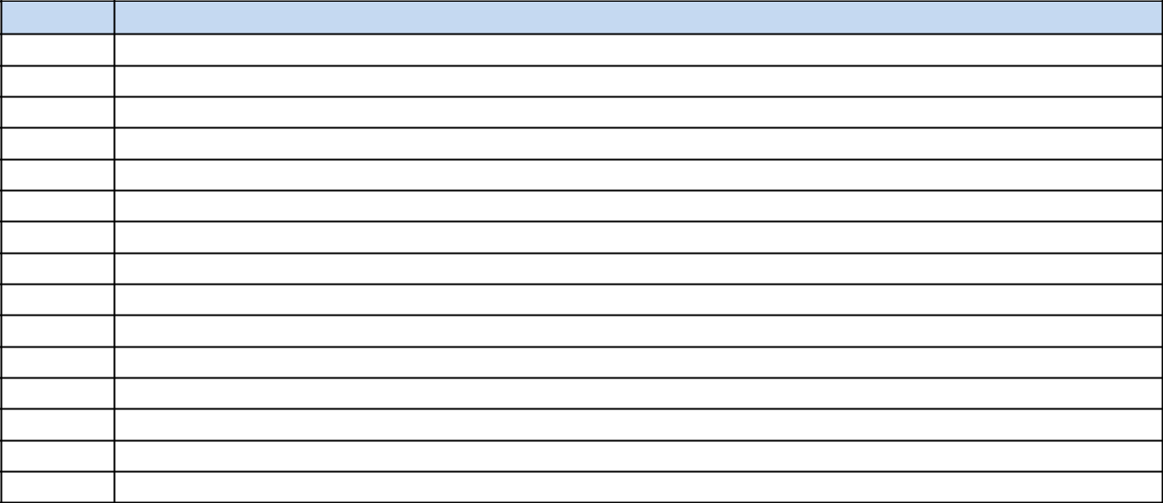
No.
Documents

Spot check was performed by: | Has participated in the spot check
 | and is familiar with the results of it:
 | I AM FAMILIAR WITH THE RESULTS:

Appendix 2 Report on Project Verification
Report of spot check

(date)


Title of the project Code of the project

- Results of project spot check
- was the spot check performed according to all verification criteria stated in the verification paper;
- has the project executor submitted all necessary information and cooperated during the spot check;
- other important information at the discretion of GWF representatives who performed the spot check.

- Conclusion of project spot check and directions (recommendations) for project executor
Conclusions, directions and recommendations are presented for the project executor in this section on:
- Management and administration of the project;
- Achievement of indicators on implementing project activities, objectives, tasks, physical activity;
- Execution of project purchase and implementation of purchase agreements;
- accounting of project financing and project funds;
- Information about the project.
Time of period is set for each recommendation to implement and it is indicated how to settle for the implementation of recommendation.

Information presented:
  - is project being implemented according to the plan;
  - can failures and weaknesses identified during the spot check have a negative impact on the further implementation of the project;
  - Had infringements been suspected after having performed the spot check of the project? If so, it is stated to initiate the procedure of infringement investigation;
  - are directions and (or) recommendations stated earlier being executed;
  - other important information.

Representatives of GWF who performed spot check:

(position, name, last name, date) (position, name, last name, date) (position, name, last name, date)

Appendix 3 Project Summary Table

PROJECT SUMMARY TABLE
(filled out separately for each project; a consolidated register of all projects is maintained in electronic form)
1. Data from the financing agreement
Application registration No. | e.g. REG/2026(1)/000
Application registration date
Applicant (project executor)
Project title
Project implementation status | Being implemented / concluded / terminated
Funding agreement No.
Funding agreement date
Start of activities
End of activities
Bank account
Planned project value, EUR | K
GWF funding, EUR | L
GWF funding intensity, proc. | M = L / K × 100
2. Payment schedule and payments
No. | Payment term based on the agreement | Amount, EUR | Factual day of payment | Notes (corrections, suspensions)
1
2
3
4
5
3. Submission and approval of reports
Reporting period | Date of receipt of the report set | Declared amount, EUR | Is the executor bankrupt or in liquidation? (checked at the Center of Registers) | Date of approval of reports
I quarter
II quarter
III quarter
IV quarter
Final report
4. Costs by category
Costs category | Based on the approved estimate, EUR | Eligible costs declared, EUR | Balance, EUR | Change, percent. (limit ±30)
1. Direct project implementation costs
2. Acquisition of fixed tangible and intangible assets
3. Unforeseen costs
4. Project administration costs
TOTAL |  |  |  | ×
Of which GWF funds |  |  |  | ×
The change is calculated as: (declared eligible costs − according to the estimate) / according to the estimate × 100. If the difference exceeds ±30 percent, the estimate must be changed in accordance with the procedure set out in Item 61 of the Guidelines.
5. Audit
Audit indicator | Calculation | Meaning / compliance
The sum of the estimate categories corresponds to the project value | 1+2+3+4 categories – project value = 0
The factual GWF funding intensity is in line with the agreement | GWF funds × 100 / declared eligible costs – percent in agreement = 0
The balance corresponds to the difference | Project value − declared eligible costs = sum of categories balances
Part of unforeseen costs | 3 category / project value × 100; limit – not more than 10 percent.
Part of administrative costs | 4 category / project value × 100; limit – not more than 30 percent; for public sector entities and for profit legal entities – 10 percent.
Balance of unused GWF funds | GWF funding − Eligible costs paid with GWF funds
6. Conclusions
Refundable GWF amount, EUR | checked after declaring all project costs
Number of publication (books, CD, DVD, etc.) copies | If applicable; 10 percent of the print run must be returned to the GWF
Identified shortcomings and deadline for their elimination
Other notes
Table filled by:
____________________  (position) | ____________________  (signature) | ____________________  (name, surname, date)

Appendix 4 Announcement on Confirmation
of the Project Report

PE “THE FOUNDATION FOR DISPOSAL OF GOOD WILL COMPENSATION FOR THE IMMOVABLE PROPERTY OF JEWISH RELIGIOUS COMMUNITIES“

Announcement regarding the project contract No.:
confirmation of the ______ quarter report
(month) (day), _________ (year) No.

Recipient:
Company:
Legal entity code:
Name of the project:

PE „The Foundation for Disposal of Good Will Compensation for the Immovable Property of Jewish Religious Communities“ (thereinafter – the GWF) hereby informs that:
- After evaluating the requested to be considered as eligible costs in the report:
  - Confirmed eligible costs of sum euro, of which the sum financed by GWF is
euro.
  - Confirmed as non-eligible costs of sum euro:

Project cost | The sum | Date of the | Serial | Title of | Supplier of | Notes
estimate line | of | document | number of | the | goods and | Notes
number and | confirmed |  | the document | document | services | Notes
title | as non- |  |  |  |  | Notes
 | eligible |  |  |  |  | Notes
 | cost |  |  |  |  | Notes
Total:

Other notes:

Contact person:
Name, last name, tel. +370 650 91521, email___________@gvf.lt

